**Best Books on Butterfly and Dragonfly Topics**

**Compiled by EDN 344 Students**

**Spring 2010**

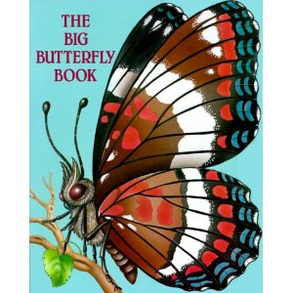

**Title:** The Big Butterfly Book

**Author:** Susanne Santoro Whayne

**Illustrator:** Rosiland Solomon

**Publisher:** Troll Associates, Inc, 1995

**Category:** Picture Book- Science

**Summary:** This book is a story but includes a lot of factual information about butterflies. It shows the life cycle of the butterfly and introduces some of the many butterflies there are.

**Curriculum Connection:** This book can be used when talking about the life-cycle in science. Especially when talking about the cycle of a butterfly. There is a lot of factual information in the book. You can have students come up with other cycles that they know about. Anything from animals to weather cycles such as seasons.

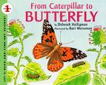

**Title:**  From Caterpillar to Butterfly

**Author:** Deborah Heiligman

**Illustrator:** Bari Weissman

**Publisher:** HarperCollins Publishers, 1996

**Category:** Picture Book- Science

**Summary:** A caterpillar is brought to the classroom. Every day the students watch the changes as the caterpillar gets larger and larger and eats the leaves that are in the jar it is in. It goes through and introduces terms that are a part of a changing caterpillar. They watch it build its house and then become a beautiful butterfly and they let watch it fly away.

**Curriculum Connection:** This book can be used during a science unit about metamorphosis and how things change and they cycle they go through. This would also be a fun class experiment to conduct. Have the students make daily observations and keep a log of what they are seeing happening. Students enjoy hands on learning and this book fits perfect in a life cycle unit.

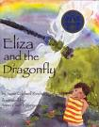

**Title:** Eliza and the Dragonfly

**Author:** Susie Caldwell Rinehart

**Illustrator:** Anisa Claire Hovemann

**Publisher:** Dawn Publications, 2004

**Category:** Picture Book- Science

**Summary:** This book shows the life cycle of a dragonfly and Eliza is right there to see it all happen.

**Curriculum Connection:** This book can also be used in the science unit on life cycles. This book is filled with facts, so while it is being read students will be asked to see if they can identify the parts of the cycle of a dragonfly while listening to the story aloud.

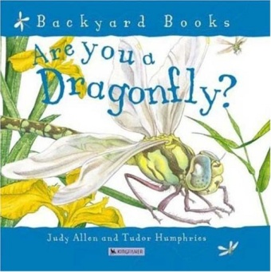

|  |  |
| --- | --- |
|  | **Title**: Are You a Dragonfly?  **Author**: Judy Allen  **Illustrator**: Tudor Humphries  **Publisher/Date:** Kingfisher 2004  **Category:** Science  **Level:** K-1 |
| **Summary:** This books talks about interesting facts about dragonflies including metamorphosis but  presents the pictures as illustrations and the information as a story.  **Curriculum Connection:** Since this book covers the life cycle of a dragonfly, students could read  the book and then create their own labeled picture or fill in a worksheet with the stages of the dragonfly  life cycle. For younger students, they could simply make their own dragonfly and talk about the stages  of the lifecycle. Or, students could act out the lifecycle.  http://www.obsessionwithbutterflies.com/img/BOOKS/Are%20you%20a%20Butterfly.jpg | |
|  | |

|  |  |
| --- | --- |
|  | **Title**: Are You a Butterfly?  **Author**: Judy Allen  **Illustrator**: Tudor Humphries  **Publisher/Date:** Kingfisher 2003  **Category:** Science  **Level:** K-1 |
| **Summary:** This book answers the title question by exploring the life and life cycle of a butterfly.  **Curriculum Connection:** Using this book as a reference point, students could work in groups to  recreate the butterfly lifecycle. This could include acting it out or drawing it out. Also, the class  could keep caterpillars as pets if possible and grow into butterflies. | |
|  | |

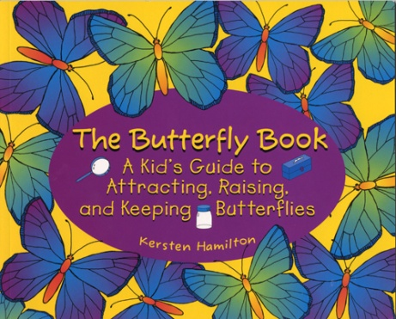

|  |  |
| --- | --- |
|  | **Title**: The Butterfly Book: A Kid's Guide to Attracting, Raising, and Keeping Butterflies  **Author**: Kersten Hamilton  **Illustrator**:  **Publisher/Date:** Avalon Travel Publishing 1997  **Category:** Science  **Level:** 1-3 |
| **Summary:** This book is a good guide for students to use about raising butterflies. It contains  good tips about how to ensure that the butterflies live as well as going into the life cycle.  **Curriculum Connection:** This book could be used as a reference at the center where students  raise caterpillars into butterflies. | |